**I have a business plan to make some money and I am looking for someone who is a US citizen or permanent resident.**

* **Do you know the Upwork site?**

Upwork is a top freelancing platform nowadays and there are a lot of opportunities there, but most of the clients are from US and they prefer to work with US devs rather than the others, also Upwork provides US only local jobs to US devs with high rates.

But unfortunately, I am not from the US. I have extensive experience in working on Upwork. I want to work on Upwork under a US account.

If you help me, I can earn money and we can share the profit from Upwork. We can earn over $5 ~ 8k every month.You will take 20% of all earnings.

Actually, I had worked with someone like this before. While I was working on his account, I had made a good income and great reputations, work histories for future Upwork freelancing. But a few months ago, unfortunately, he had to move to another country because of his family problem. That’s why I am looking for a cooperation now.

**Here is a screenshot of my work on his account.**

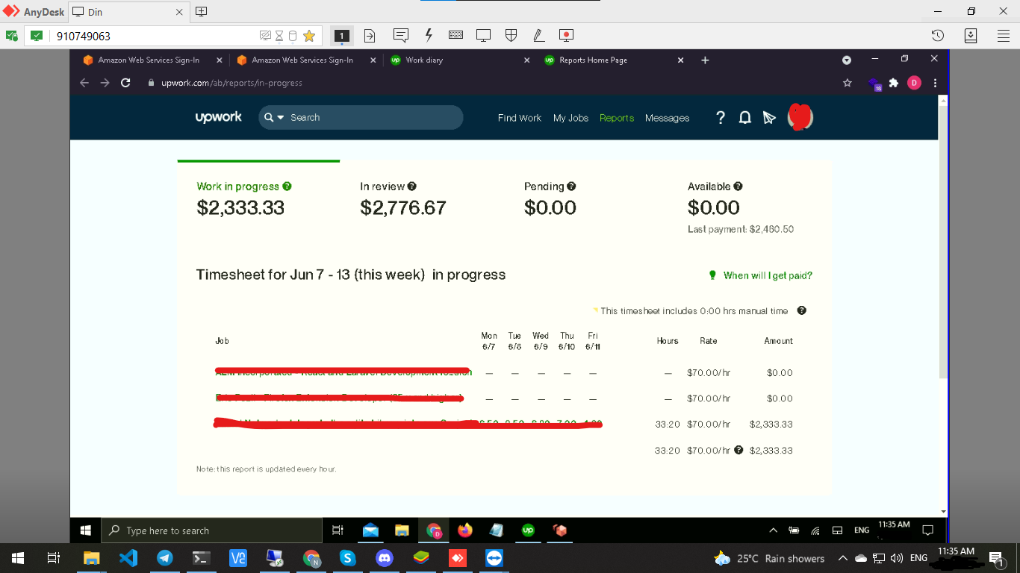

* **If we cooperate:**
* Your role
* Call with a Client on upwork

Sometimes clients require phone calls or video calls to explain their projects, so I need your help. I believe that most of them are not technical. That’s why you don’t need an expert at web development but if you don’t mind, I can help you learn the basic web development technology.

* Anydesk/ New computer

We need a computer to use your account remotely.

You will install a remote tool (Anydesk) so that I can work on your account remotely.

Why do I need to work on your computer remotely? Upwork detects location or using VPN/VPS so that I can’t use your account on my computer.

I know that it’s not comfortable to you because of personal infos so it'd be good if you have a new machine with empty data, or we can discuss it in detail.

You will charge 30% (TBD) of all profits from Upwork.

This will be a permanent contract and the contract will be made under the both sides’ agreement for each role.

Please ping me if you are interested in my plan.

Thanks for taking time to review my suggestion.

Looking forward to hearing from you.

Sincerely,

+380 99 158 1005

kalynivdenysvalentyn@gmail.com